**Exercise: Shell scripts**

1. Write a shell script to get the current date, time, username and current working directory.

#!/bin/bash

#first script

date

time

id

pwd

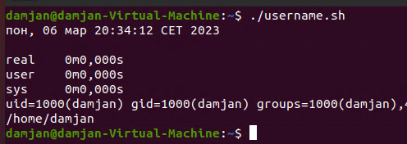

2. Write a shell script that prints “I love learning about DevOps” on the screen. Message should be a variable.

#!/bin/bash

#devops

VAR='I love learning about DevOps'

echo $VAR

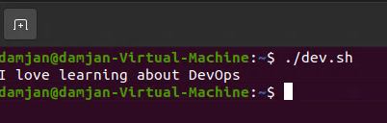

3. Write a shell script that displays “plan code build test release deploy” on the screen with each appearing on a separate line.

#!/bin/bash

var1=plan

var2=code

var3=build

var4=test

var5=release

var6=deploy

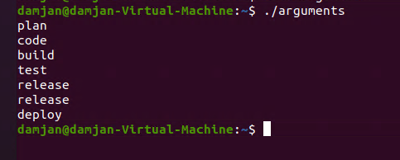echo -e "$ var1\n$ var\n$ var3\n$var4\nvar5\n$var5\nvar6"

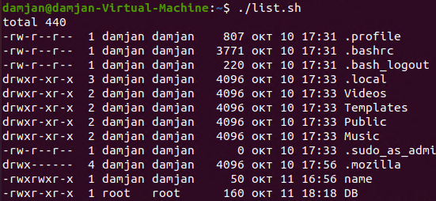4. Write a shell script that prompts the user for a name of a file or directory and reports if it is a regular file, a directory, or another type of file. Also perform an ls command against the file or directory with the long listing option.

#!/bin/bash

#user

ls -lart

5. Use arguments in a script. Total number of arguments should be three.

!/bin/bash

#arguments

arg1=damjan

arg2=gjorgievski

arg3=skopje

echo What is your name: "$arg1"

echo What is your last name: "$arg2"

echo Where are you from: "$arg3"

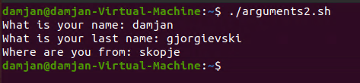

6. Write a script that till output your name out of a variable and will display the server uptime

#!/bin/bash

#myname

name=”Damjan”

echo $name

uptime

